CELL STRUCTURE

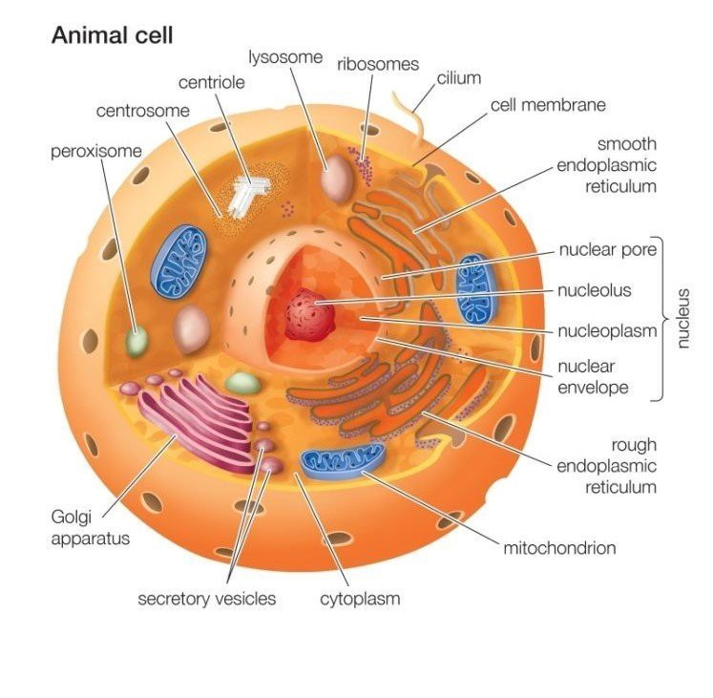

CELL MEMBRANE

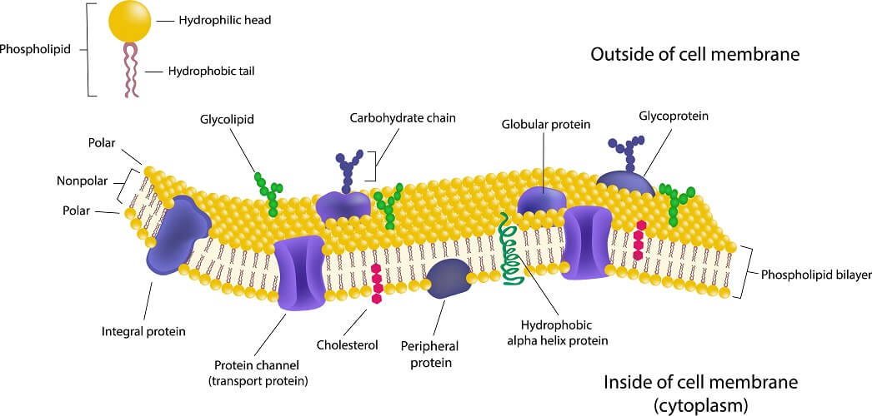

CELL TRANSPORT
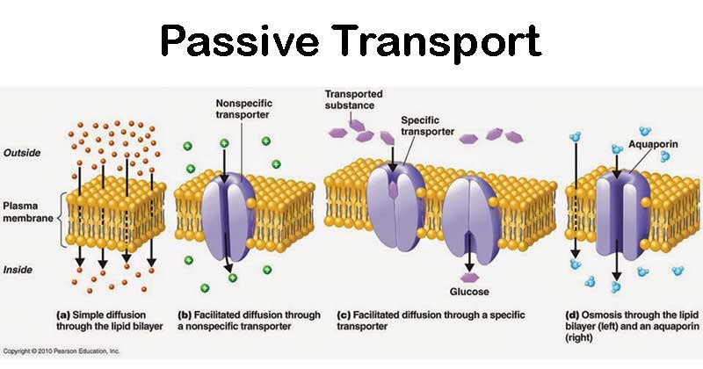
This type of transport does NOT require ATP energy. Molecules are moving from a high concentration to a low concentration. They are moving WITH the gradient.

ACTIVE TRANSPORT

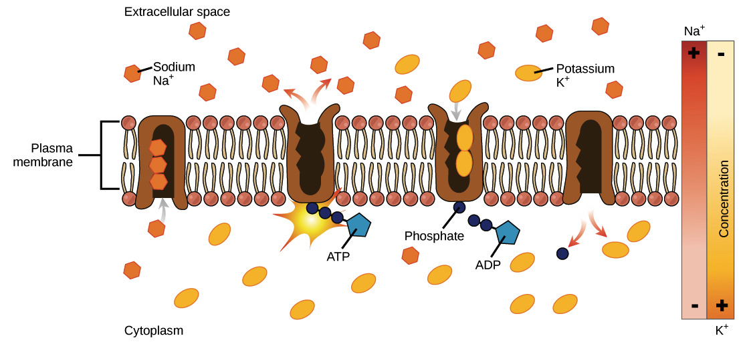
This type of transport DOES require ATP energy. Molecules are moving from a lower concentration to a high concentration. They are moving AGAINST the gradient.

ACTIVE TRANSPORT
Exocytosis & Endocytosis: Used by cells to move large molecules into or out of the cell. It requires the use of ATP energy.

